Postures of Repose.
These resting postures have been taken from the book 'muscles & meridians' by Phillip Beach.

For this exercise we are aiming to spend a short period of time in these 'mindful' resting poses to re establish holistic flexibility and balance the front and back of the body. Achieving full joint range and balance is often lost due to our 'chair height' lives and can feed into many musculo/orthopeadic conditions.
Aim to try all of the postures and then maybe rotate through them in the order outlined. If some of the postures are very difficult initially, don't lose faith and persist with a gentle approach. They can also be used after exercises to help re establish the relationship between different muscle compartments in a functionally beneficial manner. This may even have more benefit than more traditional post exercise prolonged stretches.

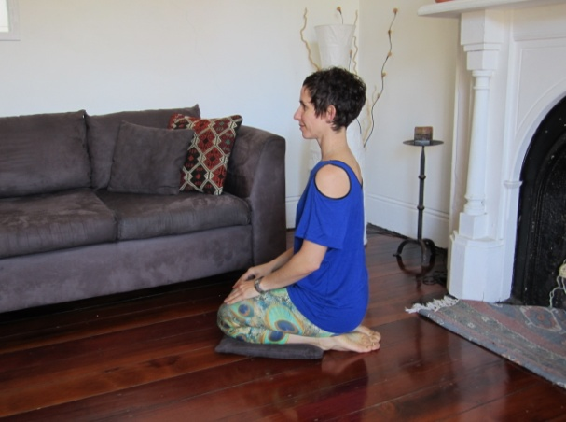
**We may benefit from putting a bolster/cushion between the knees and hips so we can rest at a different height with less pressure on the joints. Over time we should see our range increase and the ability to maintain the posture with more ease.
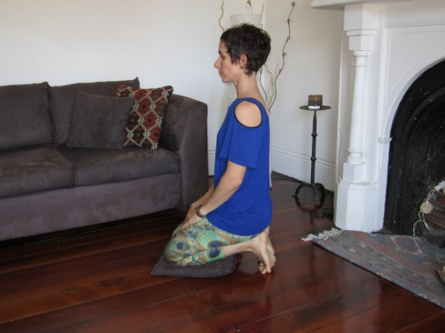

- TOE KNEEL 2. FULL KNEEL

- DRINKING POSE 4.HALF KNEEL (perform L&R)
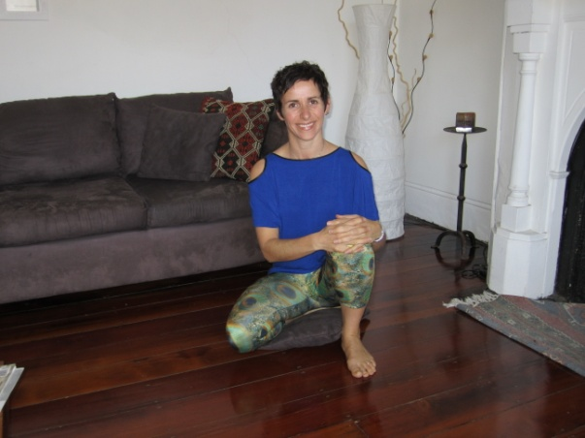
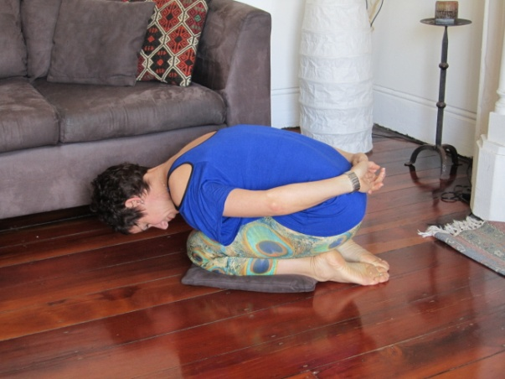

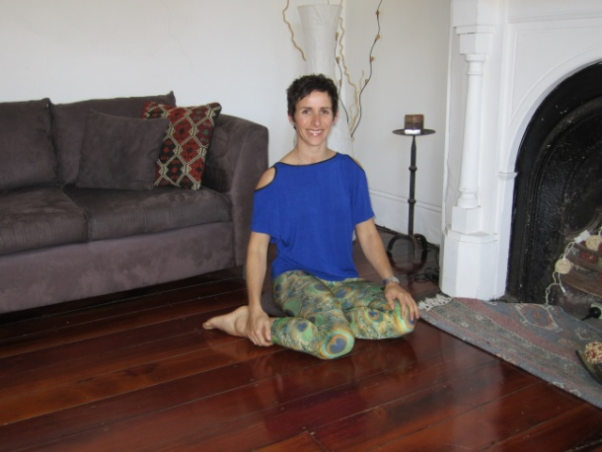
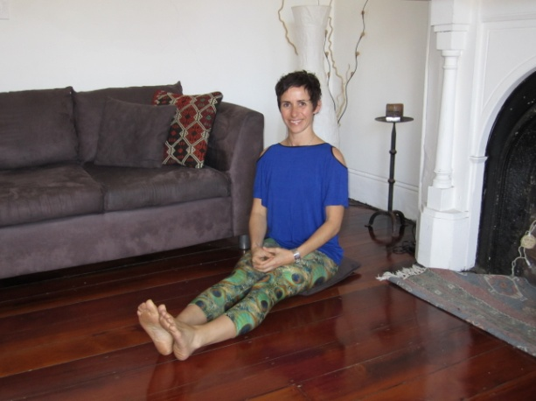

5. LONG SITTING 6. SIDE SADDLE WITH TRANSFER
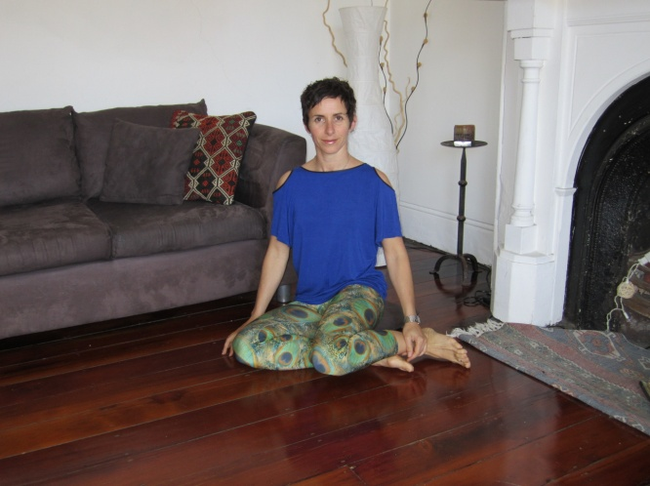
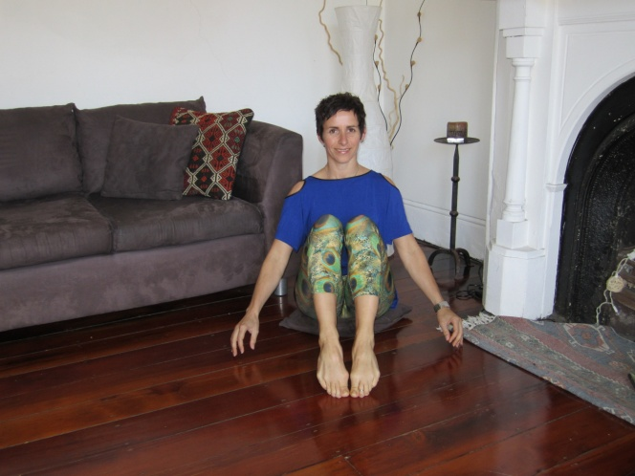

- 6/7/8 PERFORM TOGETHER; Use your abdominals to draw the knees in towards you as you move slowly from left to right sitting. Repeat 3-4 times.

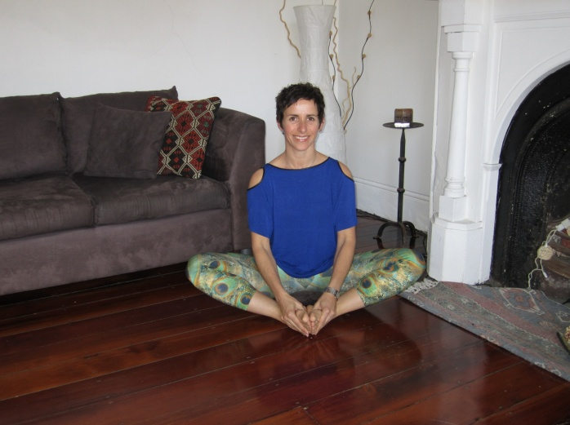
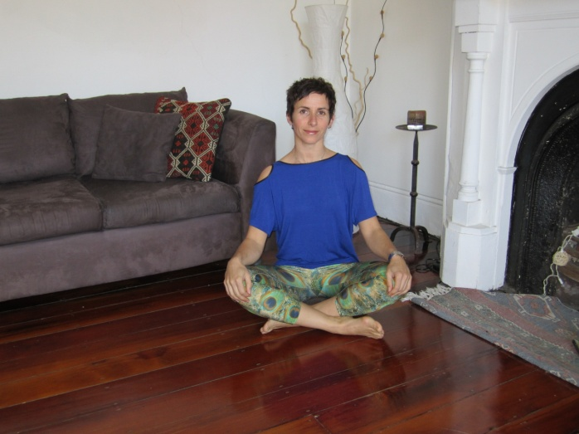
9. CROSSED LEGGED ( alternate front leg) 10. TAILORS POSE
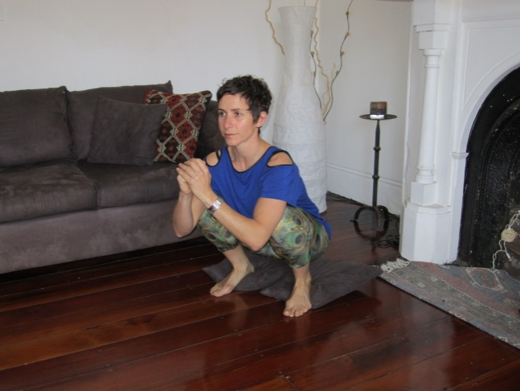
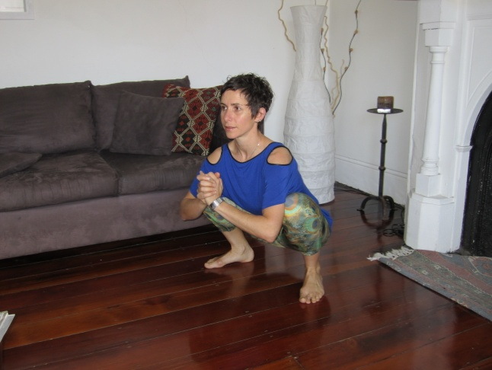
11. DEEP SQUAT SQUAT WITH HEEL SUPPORT

We want to aim to practice these postures daily. The next time you go to sit on the sofa in the evening try one of these poses for 5 minutes instead.

